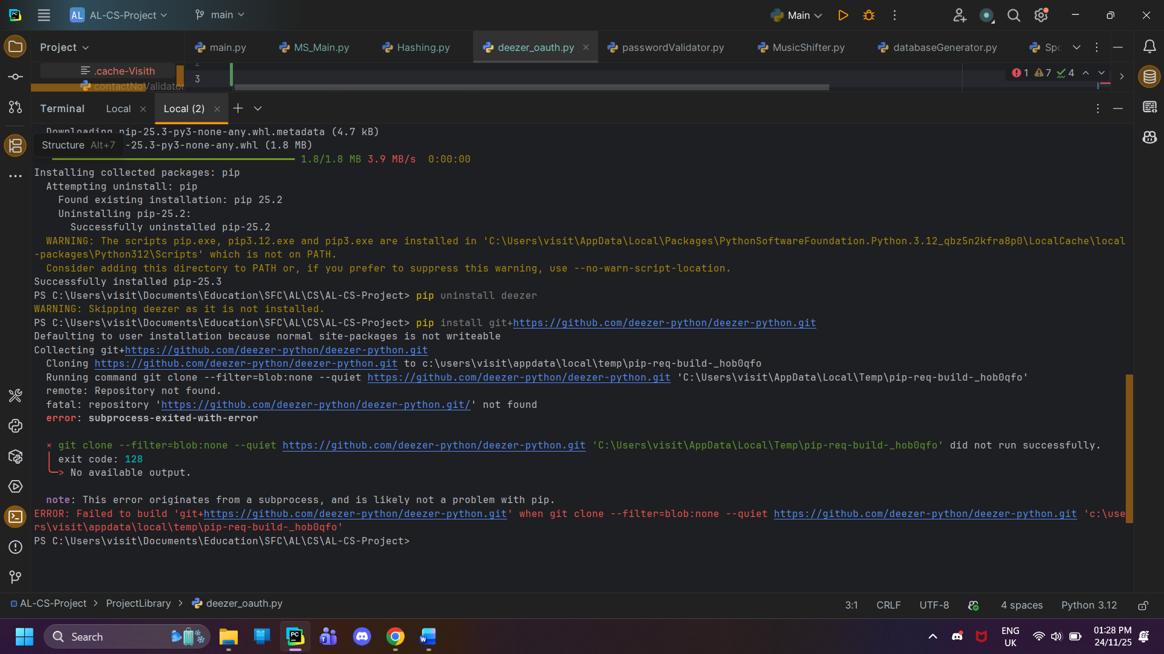

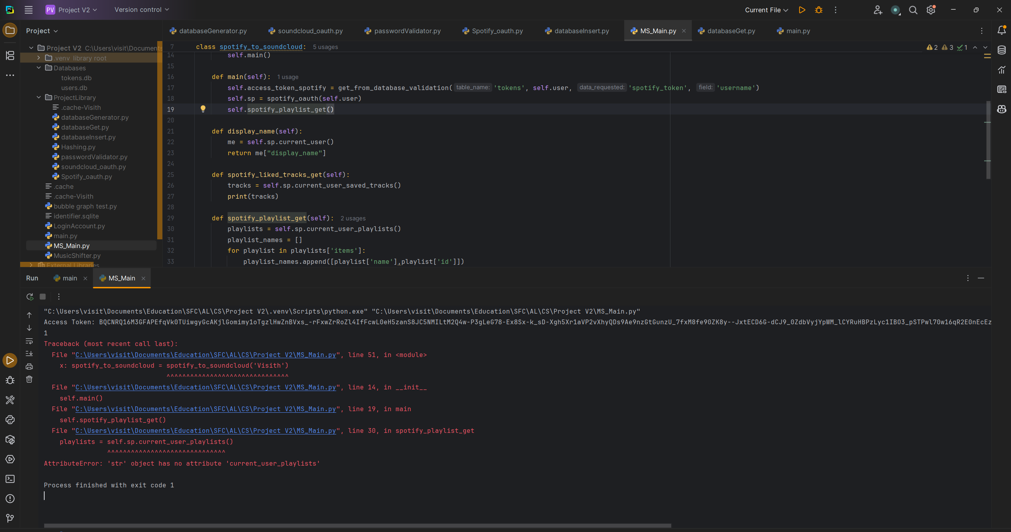
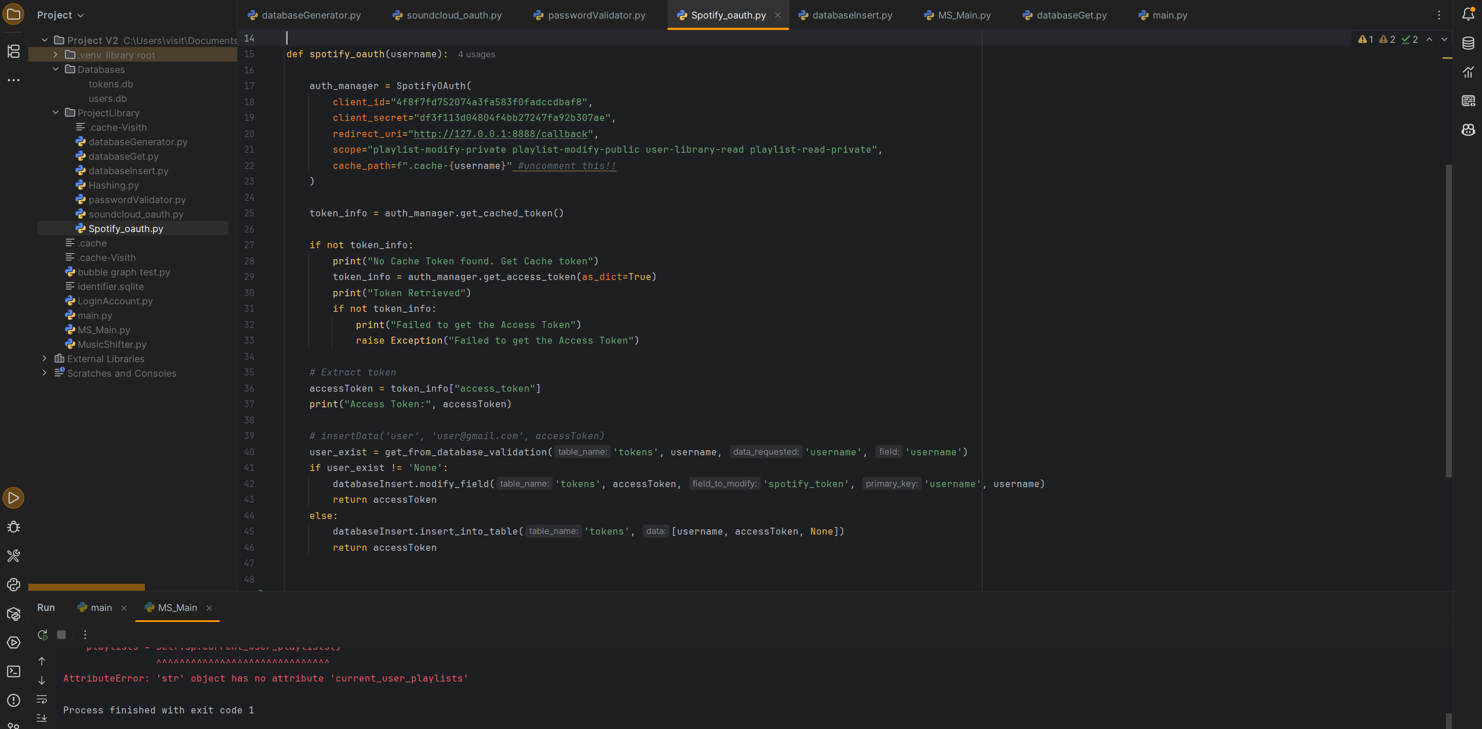

Had errors because token method is not valid in Spotipy sop had to switch to
In documentation terms, this pattern is called **using an OAuth auth manager via dependency injection**.

More concretely, for Spotipy you should describe it as:

### **“Initializing a Spotipy client using an OAuth 2.0 Authorization Code flow (via `SpotifyOAuth`)”**

---

## Precise terminology you can use (pick based on how formal you want)

### ✅ Best, accurate wording (recommended)

> **Spotify Web API client initialized with an OAuth 2.0 Authorization Code flow using an auth manager**

or shorter:

> **Spotipy client with OAuth authentication via `SpotifyOAuth`**

---

## What `auth_manager=` actually is (important concept)

From a software-engineering POV, this is:

* **Dependency Injection**
* You are injecting an **authentication handler** into the API client
* The client delegates token handling to that object

So technically:

> `Spotify(auth_manager=...)` uses **dependency injection of an OAuth token provider**

That’s a strong phrase for documentation and coursework.

---

## What it is NOT called

Just so you don’t accidentally mislabel it:

❌ Not “passing an access token”
❌ Not “API key authentication”
❌ Not “client credentials flow”
❌ Not a callback method

---

## If you want a clean one-liner for your docs

Use this — it’s accurate and marks well:

> *The application authenticates users using Spotify’s OAuth 2.0 Authorization Code flow by initializing the Spotipy client with a `SpotifyOAuth` auth manager, which automatically handles access token generation and refresh.*

That sentence is **exam-safe, industry-correct, and polished**.

If you want, tell me:

* GCSE / A-Level / Uni
* Word limit

I’ll tailor the wording to exactly what examiners expect.

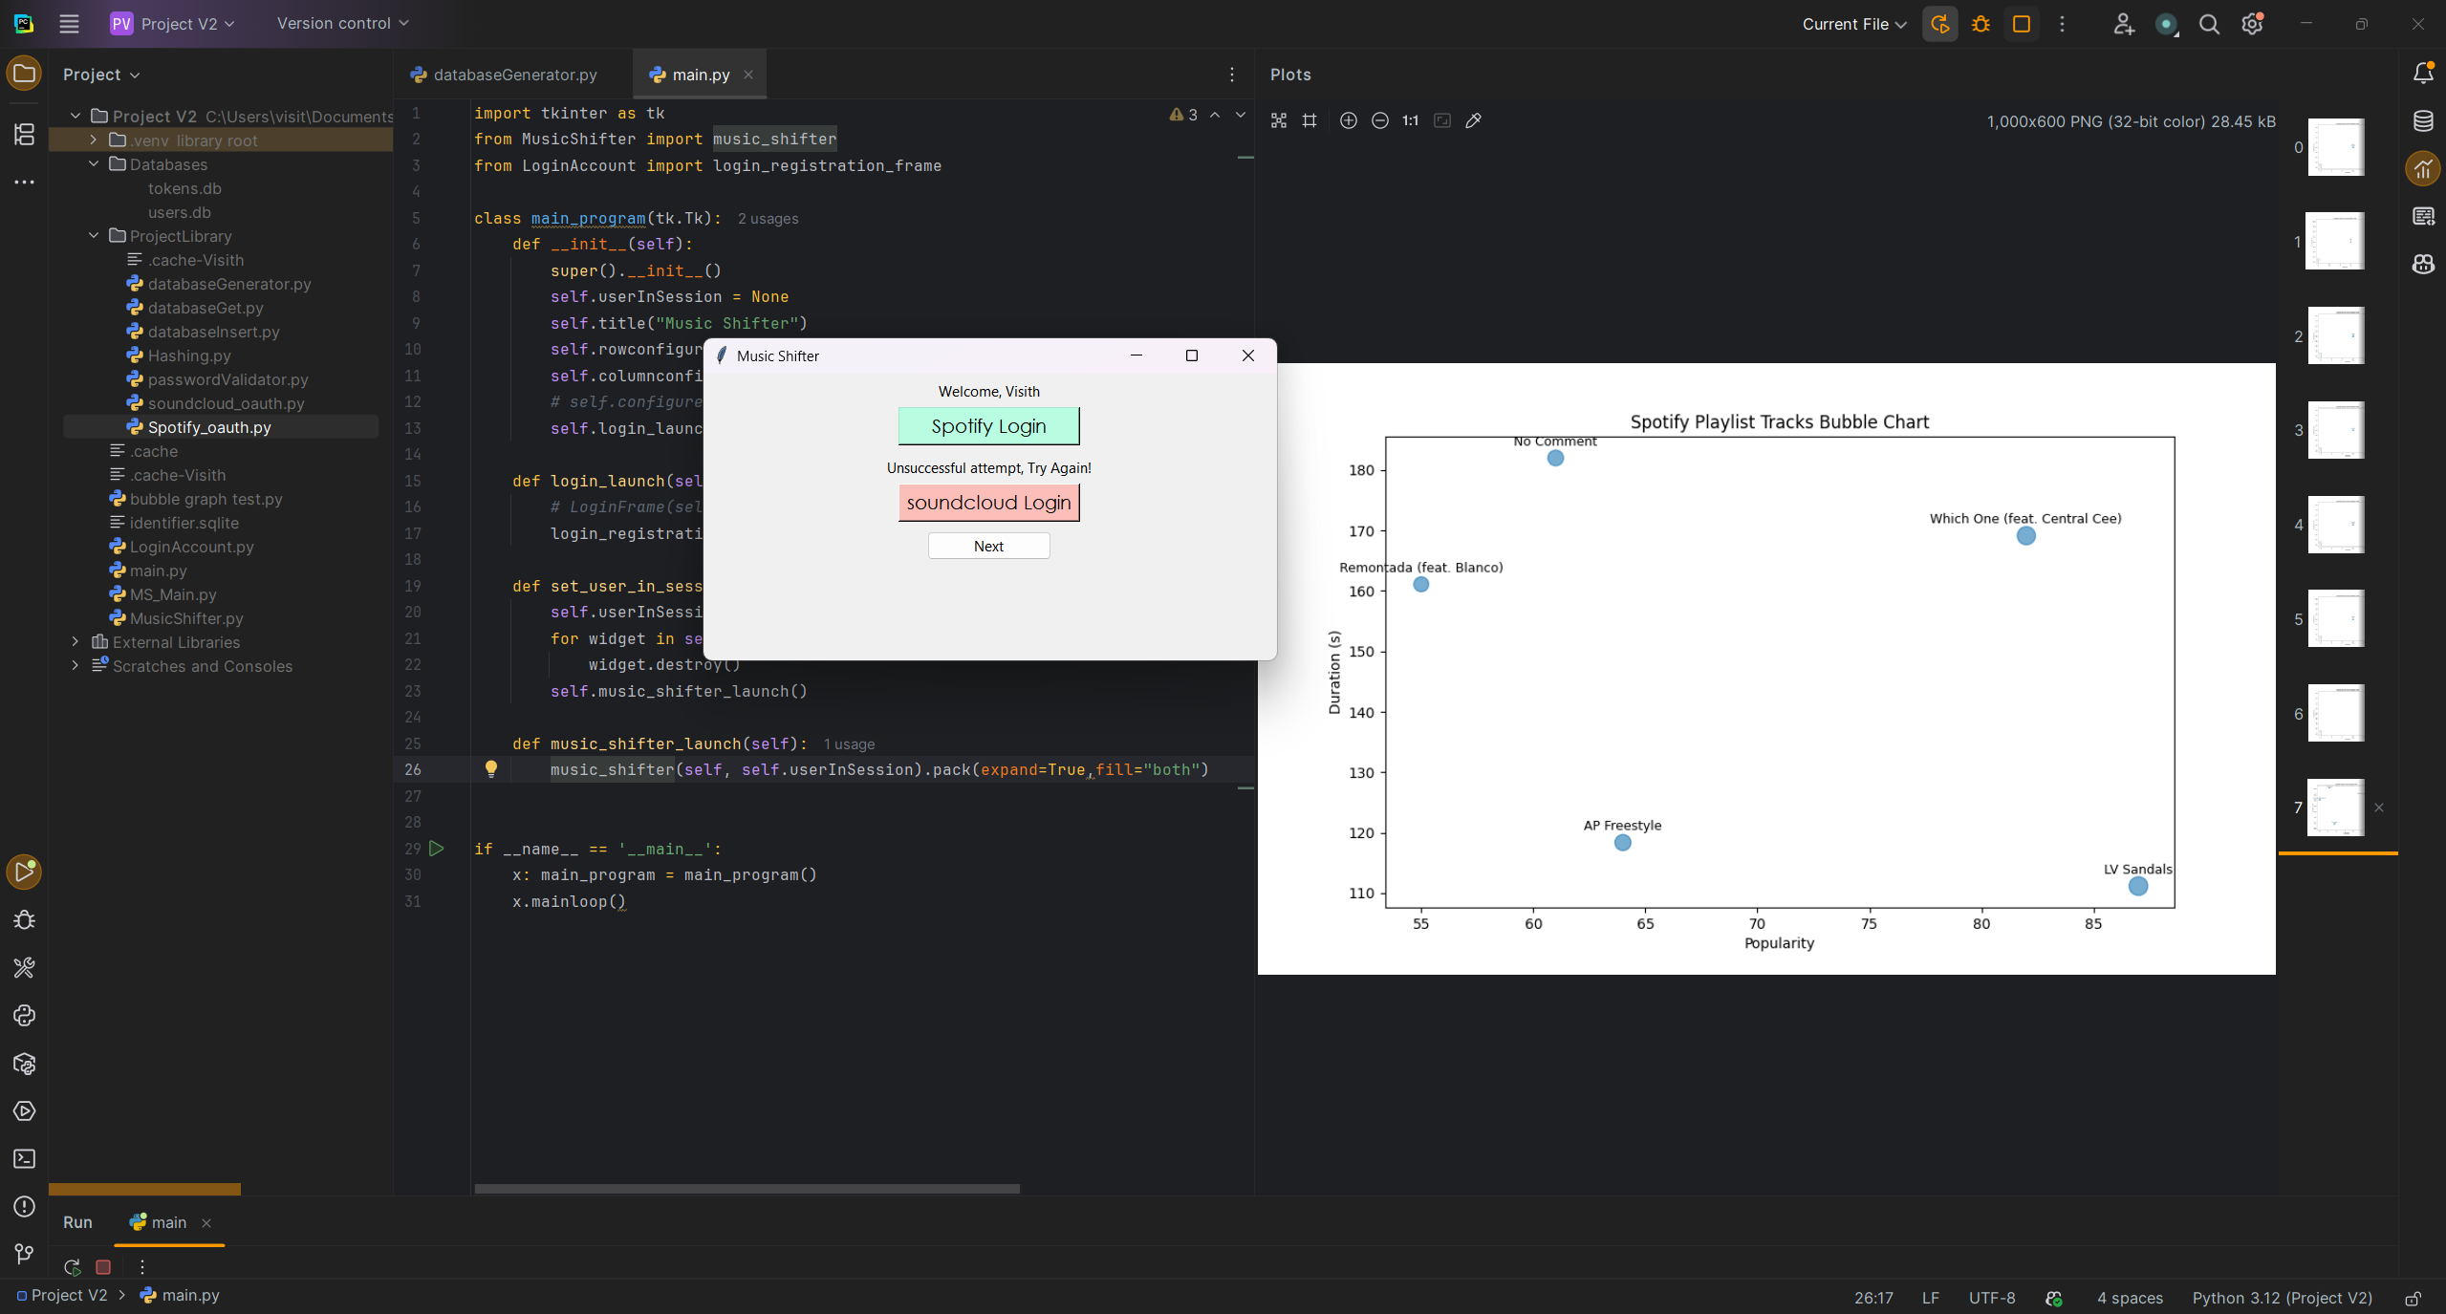

Moving from outdated official soundcloud package to json one

